**Lab Exercise #6**

**Name:** Josiah Joed G. Getes **Date:** 08/05/2021

**Class:** CSci 14 – G003

**Objectives:** To implement a function that would count the Fibonacci numbers within range using default parameters.

To implement a Collatz cycles counter.

**Materials**: Pen, Paper and C++ Compiler (MinGW using Code: Blocks IDE)

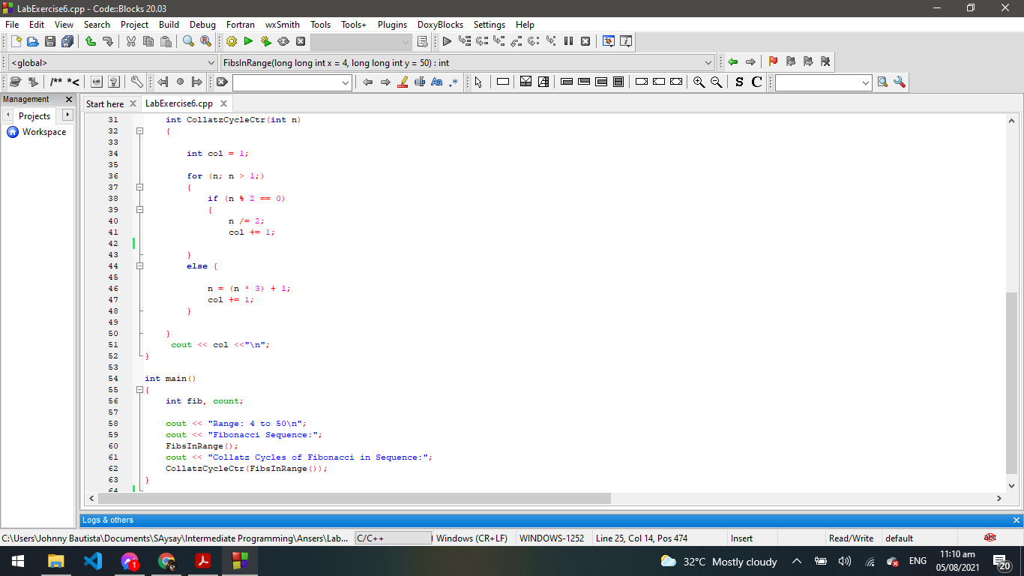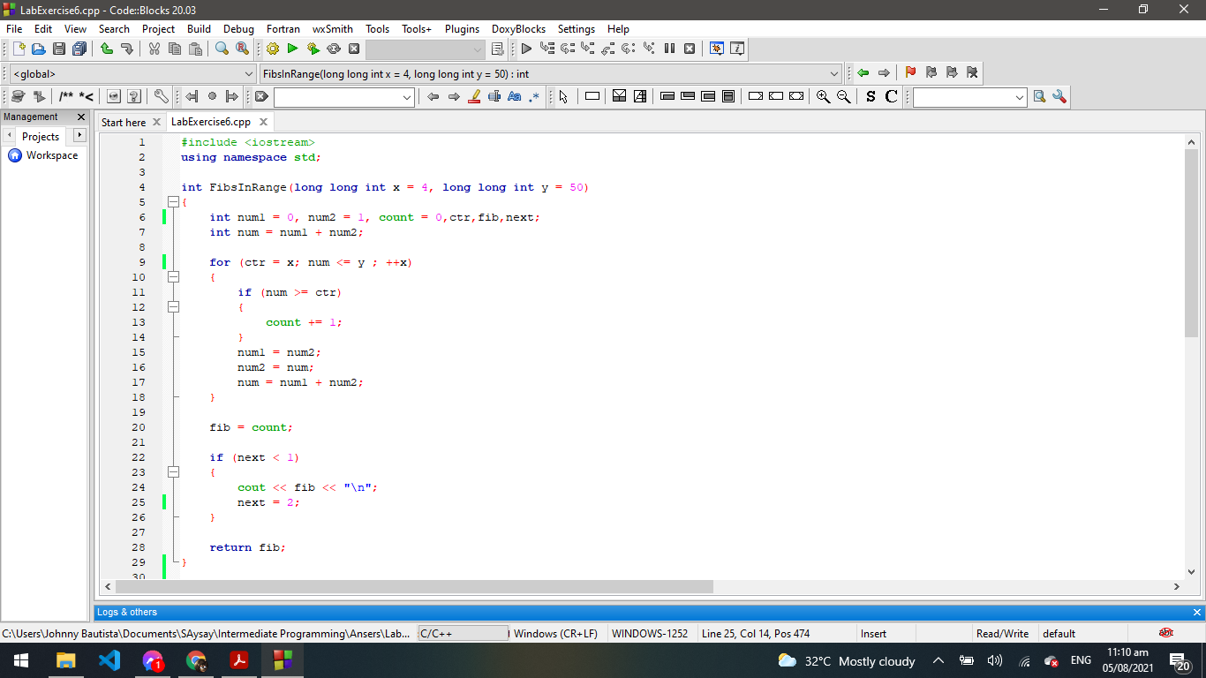

**OUTPUT:**

